A2 – Security Concepts in Public Space

- ATM Security (Authentication + Surveillance)
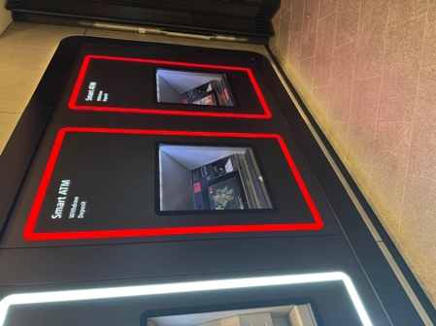

Explanation:
ATMs use authentication systems such as cards and PINs to verify users. They also include surveillance cameras to monitor activity and prevent fraud.
Concept: Authentication + Surveillance

- Shop Security Gate (Physical Access Control)
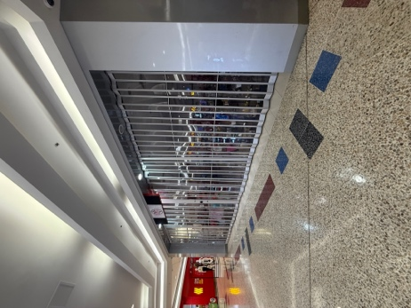

Explanation:
These gates prevent unauthorized access when shops are closed. They act as a physical barrier to protect goods.
Concept: Physical Security / Access Control

- Store Exit Control (Monitoring + Flow Control)

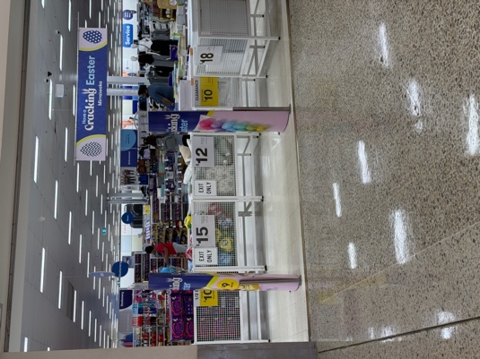

Explanation:
Exit-only gates control movement and reduce theft by guiding customers through specific paths.
Concept: Access Control + Monitoring

- PIN Pad Access System (Authentication)

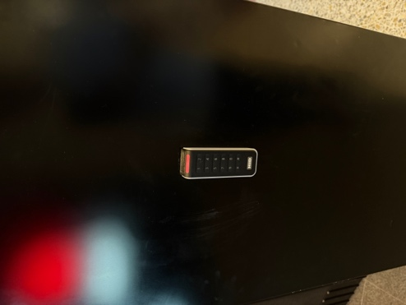

Explanation:
PIN pad systems require a code to allow access. Only authorized users who know the code can enter.
Concept: Authentication

- CCTV Camera
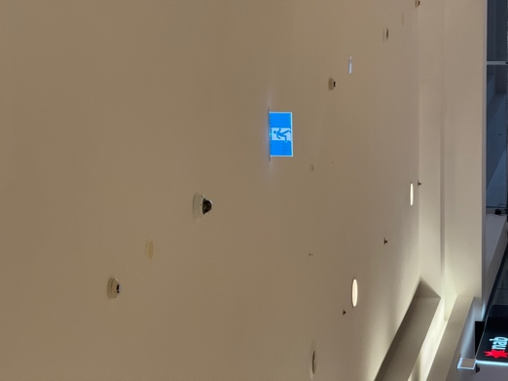

ß

Explanation:
CCTV cameras monitor activities and help prevent crime. They also provide evidence if incidents occur.
Concept: Surveillance

